1. Coconut water drink (Hemakirana Panaka) :
Ref :
- Shri Ksema Sarmakrut Ksemakutuhalam Classical Treatise on health care, Dietetics and Cookery – Culinary Science (Sanskrit Text with English Commentary) By Prof.(Dr.Gyanendra Pandey) 12/63
- Dietary Guidelines for Indians, ICMR- National Institute of Nutrition (2024)

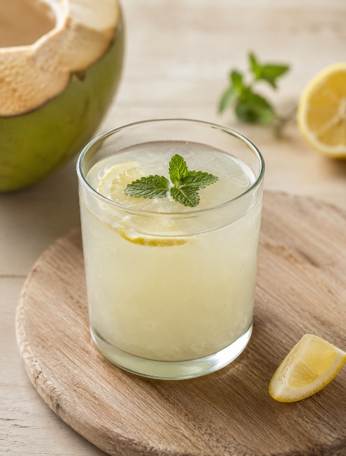
Image created with use of AI

Ingredients :
Coconut water – 150-180 ml
Rock sugar powder – 10 gm (to taste)
Citron fruit juice – 10 ml (to taste)
(Idlimbu in kannada)

Total quantity – 200 ml

Method of preparation :
Take a one glass of coconut water in vessel and add mishri / rock Sugar powder of desired quantity and stir well then add rough lemon juice up to 2 tablespoon or desired quantity and mix well.
filter it with sieve and your panaka is ready.

2. Fresh Mango Fusion (Prapanaka) :
Ref :
- Raghunathasurivirachita Bhojanakutuhalam Edited with English Translation, Notes and Illustrations by Scholars of the Centre for Theoretical Foundations (CTF), I-AIM(2012) Bhojanakutuhalam, Panak P.No:200
- Dietary Guidelines for Indians, ICMR- National Institute of Nutrition (2024)

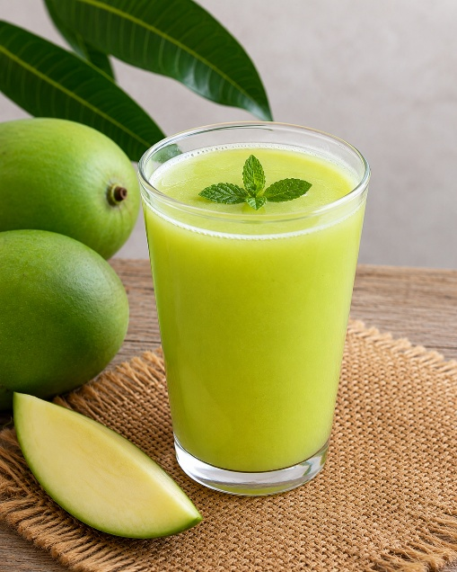
Image created with the use of AI

Ingredients :
Raw mango – 50 gm
Rock sugar – 10 gm (to taste)
Rock salt – to taste)
Aromatic powder – 1-2 gm (1/4 teaspoon)
(Cardamom – 3-4, Clove – 2-3, Pepper – 2-3, Cinnamon – 2-3inch, Dry ginger – 2-3 inch, Edible camphor (pacha karpooram) – 2-3 small crystals – make all them into fine powder)

Total quantity – 200 ml

Method of preparation :
- Take a raw mango wash it thoroughly and boil it properly in a pressure cooker or a vessel until it becomes soft and well cooked.
- Allow it to cool completely then remove the outer layer of mango and squeeze it well by hand until it forms a smooth liquid paste consistency.
- Add desired quantity of rock sugar to it and cold water (not refrigerated water) as needed until the mixture reaches the desired panaka consistency.
- Add aromatic powder to it and stir it well
- Now you can have it.

3. Golden Essence (Dhanyaka panaka):

Ref :
- Raghunathasurivirachita Bhojanakutuhalam Edited with English Translation, Notes and Illustrations by Scholars of the Centre for Theoretical Foundations (CTF), I-AIM(2012) Bhojanakutuhalam, Panak Prakarana P.No:201
- Dietary Guidelines for Indians, ICMR- National Institute of Nutrition (2024)

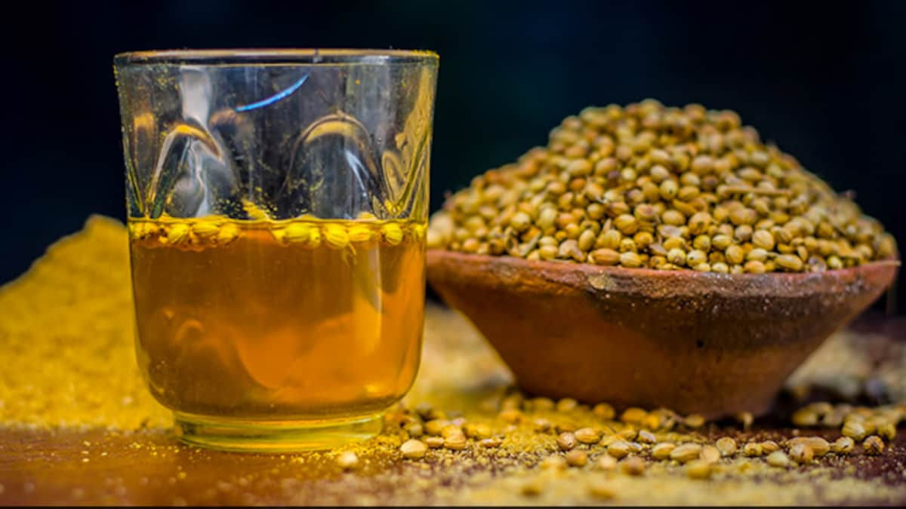
Credit:https://c.ndtvimg.com/2022-09/lo5etirg_coriander-water-health-benefits_625x300_21_September_22.jpg?im=FaceCrop,algorithm=dnn,width=1200,height=675

Ingredients :
Coriander seeds – 10 gm (2 teaspoon)
Sugar – 15 gm (to taste)
Edible camphor (pacha karpooram) – one pinch
Water – 200 ml (as needed)

Total quantity : 200 ml
Method of preparation :
- Take coriander seeds wash them thoroughly and soak for 20-30min. in water
- Macerate thoroughly by using mortar and pestle or grinding slab, filter it through a cloth by adding sufficient quantity of water then add desired quantity of rock sugar powder to it and also add fine powder of edible camphor mix it well then have it.

4. Citrus Spark(Amalaki panaka) :
Ref : Traditional food recipes from Ayush systems of medicines

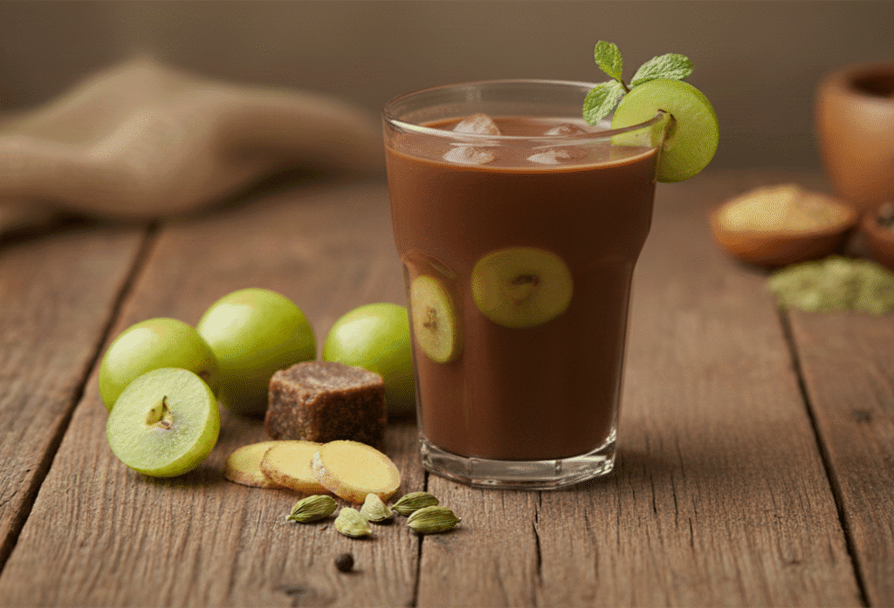
https://devpathshala.com/wp-content/uploads/2025/12/Gemini_Generated_Image_msj5srmsj5srmsj5-1024x697.png

Ingredients :
Fresh Amala – 80 gm
Dry ginger powder – 1 gm (1/4 teaspoon)
Cardamom powder – 1 gm (1/4 teaspoon)
Rock sugar / Jaggery – 30 gm (to taste)
Rock salt – 0.5 – 1 gm (to taste)
Honey – 5 gm (1 teaspoon)
Water – 200ml ( as needed)

Total quantity : 200 ml

Method of preparation :
- Take an amla and wash thoroughly cook on the steam, cut and remove the seeds and allow the amla to cool, then grind it to make smooth paste,
- Take the smooth paste in a vessel and add 1 glass of water, mix it well.
- Add dry ginger powder, cardamom powder, Rock sugar / Jaggery as per taste, a pinch of salt and also add required quantity of honey and stir it well
- Have it as fresh.

5. Sweet Elixir (Sharkarodak) :
Ref :
- Bhojana Kutuhala Siddhannaprakarana (Panaka prakarana), p.199
- Dietary Guidelines for Indians, ICMR- National Institute of Nutrition (2024)

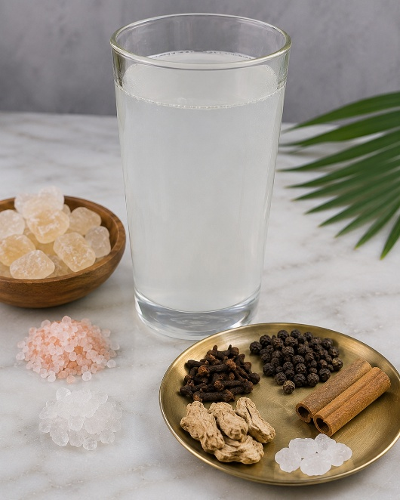
Image created with the use of AI

Ingredients :
Water – 200 ml
Rock sugar – 20 gm (4 teaspoon)
Rock salt – to taste
Aromatic powder – 1-2gm (1/4 teaspoon)
(Cardamom – 3-4, Clove – 2-3, Pepper – 2-3, Cinnamon – 2-3inch, Dry ginger – 2-3 inch, Edible camphor (pacha karpooram) – 2-3 small crystals – make all them into fine powder)

Total quantity : 200 ml

Method of preparation :
Take a glass of cold water (not refrigerated water) in a vessel add desired quantity of rock sugar and stir well until the sugar dissolves completely. After that add aromatic powder to it and mix well. Have it as per requirement

6. Sunshine Sip(Kharjuradi Mantha):

Ref : Traditional food recipes from Ayush systems of medicines

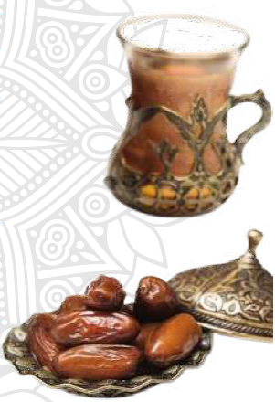
Credit:https://www.google.com/imgres?imgurl

Ingredients :
Seedless grapes – 15 gm (3 teaspoon)
Soft dates – 10 gm
Rosted puffed paddy – 7-8gm (1-2 teaspoon)
Jaggery – 5 gm (1 teaspoon)
Water – 150 ml (as needed)

Total quantity : 200 ml

Method of preparation :
Take a bowl and soak seedless grapes and soft dates with required quantity of water up to 1hr. after that take a mixer grinder and add the soaked seedless grapes and soft dates along with water. And also roasted puffed paddy and required quantity of jaggery and required quantity of water and blended smoothly then have it as fresh.

7. Amla squash:

Ref : Traditional food recipes from Ayush systems of medicines
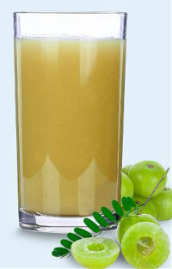
Credit:https://www.liveayurved.com/ayurveda_recipes/images/amla_squash.jpg

Ingredients :
Amla – 2
Candy sugar – to taste
Rock salt – to taste
Roasted cumin seed powder – ½ teaspoon
Pepper powder – ¼ teaspoon
Black salt – to taste
Water – 150 – 170 ml (as needed)

Total quantity : 200 ml

Method of preparation :
- Take 2 amla and wash thoroughly, boil them properly, cut and remove the seeds and allow the amla to cool, then grind it to make smooth paste,
- Take a vessel add required quantity of sugar and water to make a proper sugar syrup (one strand) on medium flame. As the double quantity of the paste.
- Take the pulp in a vessel and slowly add sugar syrup and mix it well. When the pulp and syrup are properly mixed, water is added if required, then add required quantity of rock salt, ½ tsp. of roasted cumin seed powder, ¼ tsp. of pepper powder and a pinch of black salt,
- Stir it well then have it as fresh.

8. Masala curd (Rasala) :

Ref : Traditional food recipes from Ayush systems of medicine

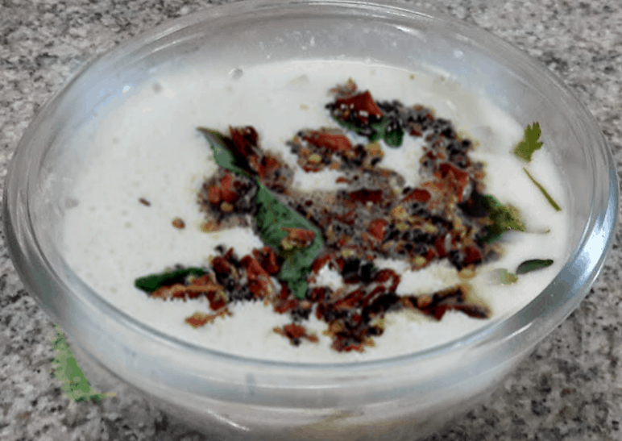
Credit:https://healthylife.werindia.com/wp-content/uploads/2021/06/RASALA-Medicated-Curd-HealthyLife-WeRIndia.png

Ingredients :
Fresh curd – 100 ml (1/2cup)
Pepper powder – 3 gm (1/2 teaspoon)
Jaggery / sugar – 10 gm (to taste)
Salt – 2 gm (to taste)
Ghee / Butter – 5 ml (1 tsp)
Mustard – 5 gm (1 tsp)
Fenugreek – 3 gm (½ tsp)
Cumin seeds – 3 gm (1/2tsp)
Crushed red chilli (choice) – as per taste
Curry leaves – 5-6

Total Quantity – 200-250 ml

Method of preparation :
- Pepper powder, Jaggery / Sugar and Salt are added to fresh curd and blended well using a blender or traditional churning.
- Heat butter / ghee in a pan, splutter mustard seeds, add fenugreek seeds, red chillies and curry leaves and use it for seasoning.
- Salt can be used in place of jaggery / sugar as per the taste and requirement.
- Rasala is ready to serve with roti, rice etc.

9. Masala buttermilk (Rasala) :

Ref : Traditional food recipes from Ayush systems of medicine

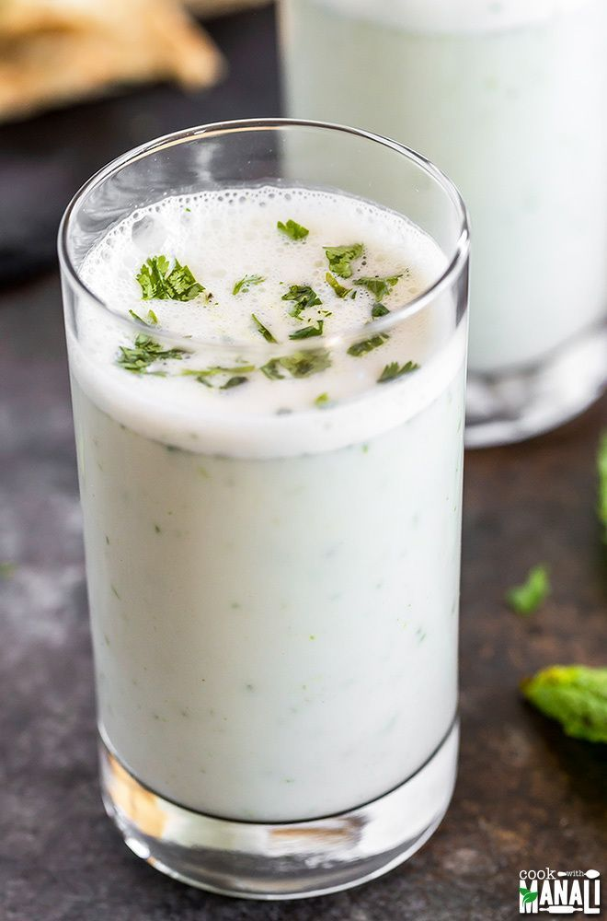
Credit:https://i.pinimg.com/736x/8c/2f/00/8c2f00867d06a124a1a99ca03e65a0f0.jpg

Ingredients :
Fresh curd – 100 ml (1/2 cup)
Pepper powder – 3 gm (1/2 teaspoon)
Jaggery / sugar – 10 gm (to taste)
Salt – 2 gm (½ teaspoon)
Ghee / Butter – 5 gm (1 teaspoon)
Mustard – 5 gm (1 teaspoon)
Fenugreek – 3 gm (½ tsp)
Cumin seeds – 3 gm (1/2tsp)
Crushed red chilli (choice) – as per taste
Curry leaves – 5-6 leaves
Half lemon juice – 5 10 ml (to taste)
Water – 60 – 80 ml (as needed)

Total Quantity – 200-250 ml

Method of preparation :
- Pepper powder, Jaggery / Sugar and Salt are added to fresh curd and add required quantity of water blended well using a blender or traditional churning.
- Heat butter / ghee in a pan, splutter mustard seeds, add fenugreek seeds, red chillies and curry leaves and use it for seasoning and add lemon juice and mix it well then have it as fresh.
- Salt can be used in place of jaggery / sugar as per the taste and requirement.

10. Tempered Buttermilk (Khalam) :

Ref :Traditional food recipes from Ayush systems of medicines

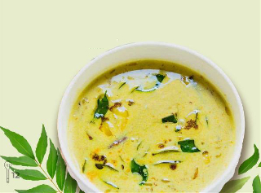

Credit:https://www.liveayurved.com/ayurveda_recipes/images/khalam.jpg

Ingredients :
Buttermilk – 150 ml (3/4 cup)
Fresh Ginger paste – 5 gm ( 1 teaspoon)
Hingu – one pinch
Turmeric powder – 1-2 gm (1/4 teaspoon)
Rock salt – to taste
Pepper powder – 1-2 gm (1/4 teaspoon)

Total Quantity – 150-160 ml

Method of preparation :
Take vessel and heat buttermilk on medium flame add fresh ginger paste to boiling buttermilk and further boil it for a min. and add turmeric powder, pepper powder, hingu and rock salt as per the taste mix it well then turn off the flame. And have it.

11. Greengram soup:

Ref :
- Shri Ksema Sarmakrut Ksemakutuhalam Classical Treatise on health care, Dietetics and Cookery – Culinary Science (Sanskrit Text with English Commentary) By Prof.(Dr.Gyanendra Pandey) 6/25-26
- Ref : Dietary Guidelines for Indians, ICMR- National Institute of Nutrition (2024)

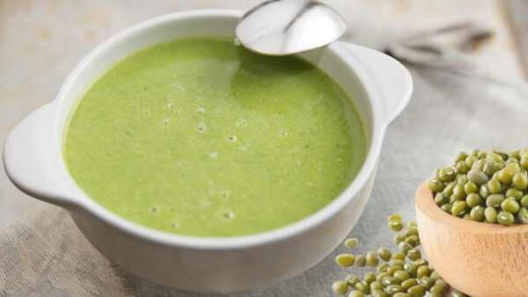
https://www.happiesthealth.com/wp-content/uploads/2024/08/Green-gram-soup-600x338.jpg

Ingredients :
Green gram – 30 gm (2 tablespoon)
Water – 300 ml (as needed)
Rock salt – to taste
Pepper – 1-2 gm (¼ teaspoon)
Ghee – 5 gm (1 teaspoon)
Mustard seeds – 1-2 gm (1/4 teaspoon)
Fenugreek seeds –1-2 gm (1/4 teaspoon)
Curry leaves – 4-5 leaves
Lemon juice – to taste

Total Quantity – 200 ml

Method of preparation :
- Wash the green gram thoroughly and soak it in water for 4-5 hrs.
- Add the soaked green gram to a pressure cooker or vessel with sufficient quantity of water.
- Cook until the green gram becomes soft and well cooked.
- Then mash lightly or blend partially to obtain a smooth soup like consistency.
- Heat ghee in a small pan add mustard seeds and allow them to splutter then add fenugreek seeds and 3-4 curry leaves then pour this into the smooth soup
- Then add rock salt as per the taste add roasted black pepper powder as per the taste and add lemon juice then mix it well then have it.

12. Blackgram Soup :

Ref :
- Shri Ksema Sarmakrut Ksemakutuhalam Classical Treatise on health care, Dietetics and Cookery – Culinary Science (Sanskrit Text with English Commentary) By Prof.(Dr.Gyanendra Pandey) 6/27
- Dietary Guidelines for Indians, ICMR- National Institute of Nutrition (2024)

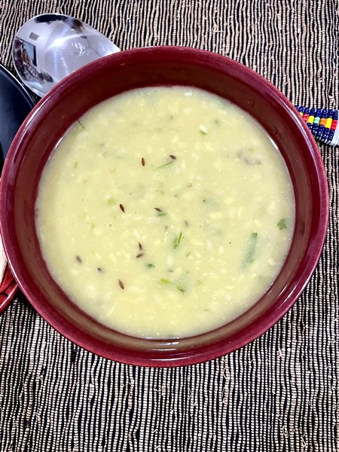
https://healthy-indian.com/wp-content/uploads/2023/01/IMG_6859.jpg

Ingredients :
Black gram – 30 gm (2 tablespoon)
Water – 300 ml ( as needed)
Rock salt – to taste
Pepper – 1-2 gm (¼ teaspoon)
Ghee – 5 gm (1 teaspoon)
Mustard seeds – 1-2 gm (1/4 teaspoon)
Fenugreek seeds – 1-2 gm (¼ teaspoon)
Curry leaves – 4-5 leaves
Lemon juice – to taste

Total Quantity – 200 ml

Ref : Dietary Guidelines for Indians, ICMR- National Institute of Nutrition (2024)
Longvah T, et al. Indian Food Composition Tables (IFCT)2017. ICMR-National Institute of Nutrition,
Hyderabad.
Method of preparation :
- Wash the Black gram thoroughly and soak it in water for 4-5 hrs.
- Add the soaked black gram to a pressure cooker or vessel with sufficient quantity of water, cook until the black gram becomes soft and well cooked.
- Then mash lightly or blend partially to obtain a smooth soup like consistency.
- Heat ghee in a small pan add mustard seeds and allow them to splutter then add fenugreek seeds and 3-4 curry leaves then pour this into the smooth soup then add rock salt as per the taste
- Add roasted black pepper powder as per the taste and add lemon juice then mix it well, then have it.

13. Green Soup:

Ref :Traditional food recipes from Ayush systems of medicine

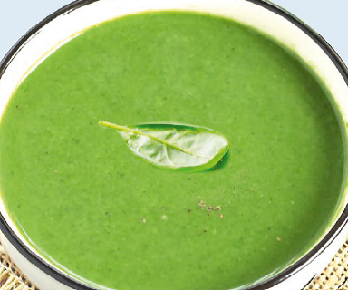
Credit:https://static.vikaspedia.in/mediastorage/image/GREEN_SOUP.png

Ingredients :
Fenugreek Leaves/ Spinach / Any green leafy vegetables – 50 gm (1/4 cup)
Finely chopped onion – 50 gm (1/4 cup)
Finely chopped ripe tomato – 50 gm (1/4 cup)
Garlic cloves – 3-4
Dal water (supernatant of boiled pulses) – 200-400 ml
Oil – 5 ml (1 teaspoon)
Salt – to taste
Pepper powder – 1-2 gm (1/4 teaspoon)

Total Quantity – 200 ml

Method of preparation :
- Take a pan heat oil on medium flame then add chopped onion and garlic paste fry onion well, add chopped tomato and cook for a few minutes.
- Now add cleaned and chopped green leaves and fry until they soften, then add diluted dal water, add salt as per the taste and leave it for 15 minutes to cook properly.
- Take half quantity of this soup and leave it to cool, once it cools down blend it perfectly and add this to the rest of the soup and simmer for another 5 minutes.
- Add pepper powder to this as per the taste and mix it well then have it.

14. Sweet potato soup : P. No: 99

Ref : Morningstar A. Ayurvedic Cooking for All: Familiar Food Prepared with Ayurvedic Principles. 3rd reprint. New Delhi: Motilal Banarsidass Publishers Pvt. Ltd.; 2011. p. 99

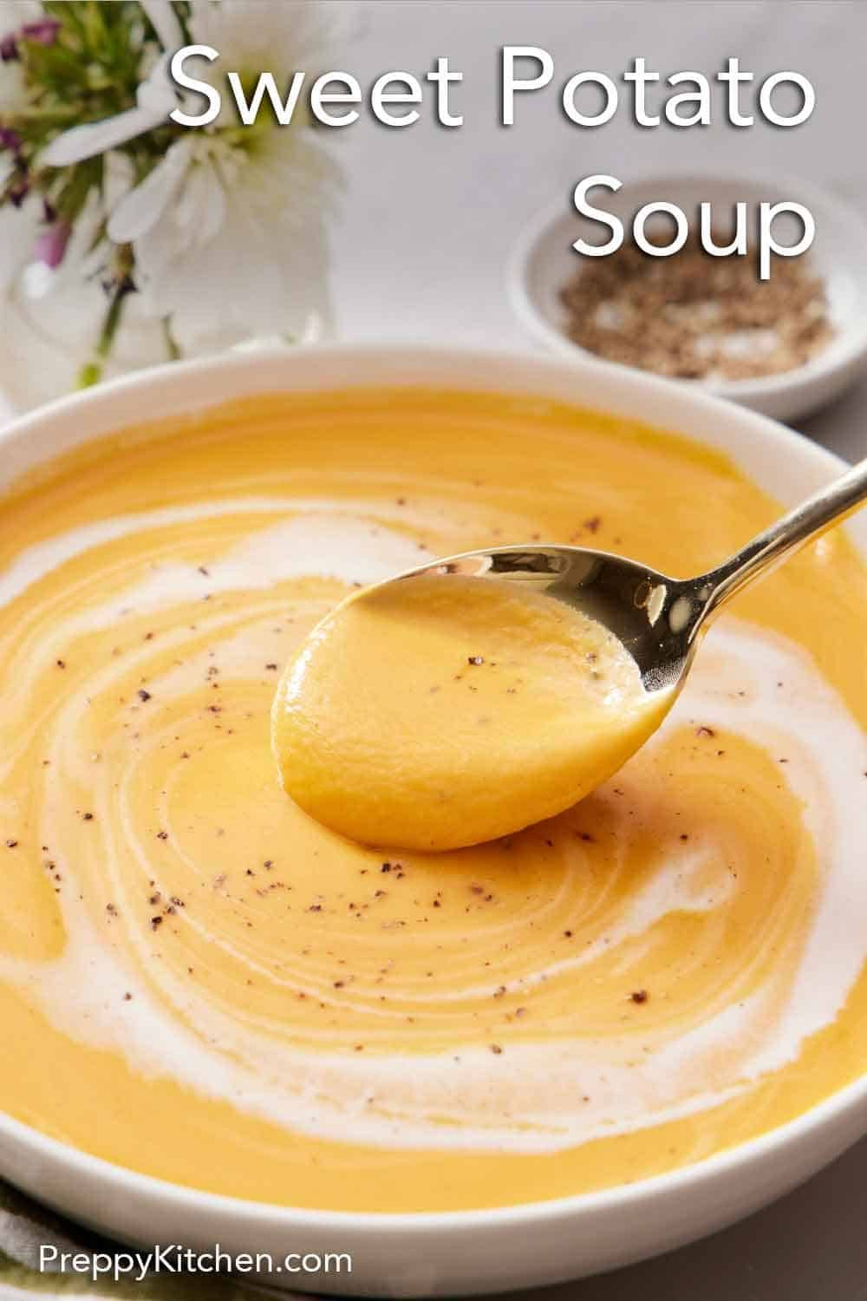
Credit:https://i.pinimg.com/originals/50/73/a1/5073a13b42f0e67d558215aa2e780cf5.jpg

Ingredients :
Sweet potato – 200 gm
Fresh ginger – 6 gm
Cow’s milk – 90-100 ml
Sugar – optional (5gm)
Rock salt – 1 gm (as per taste)
Spices – as your wish
Pepper powder – 1-2 gm (1/4 teaspoon)

Total quantity : 350-400 ml

Method of preparation :
- Boil the sweet potato along with fresh ginger up to the sweet potato becomes soft.
- Take a grinder add boiled and peeled sweet potato, chopped and boiled ginger, hot milk, pinch of rock salt, sugar as per the taste it is optional and add any spices you like with proper quantity along with pepper powder.
- Add some water grind till the mixture turns in to smooth paste.
- Add more milk or water as desired to reach a creamy consistency then have it as fresh and hot.

15. Beet Borscht

Ref : Morningstar A. Ayurvedic Cooking for All: Familiar Food Prepared with Ayurvedic Principles. 3rd reprint. New Delhi: Motilal Banarsidass Publishers Pvt. Ltd.; 2011. p. 103

Ingredients :
Sliced Beetroot – 200 gm (1 cup)
Fresh ginger – 5-6
Olive oil – 5-7 ml (1 teaspoon)
Rock salt – to taste
Black pepper powder – to taste

Total quantity : 450-500 gm

Ref : Morningstar A. Ayurvedic Cooking for All: Familiar Food Prepared with Ayurvedic Principles. 3rd reprint. New Delhi: Motilal Banarsidass Publishers Pvt. Ltd.; 2011. p. 103

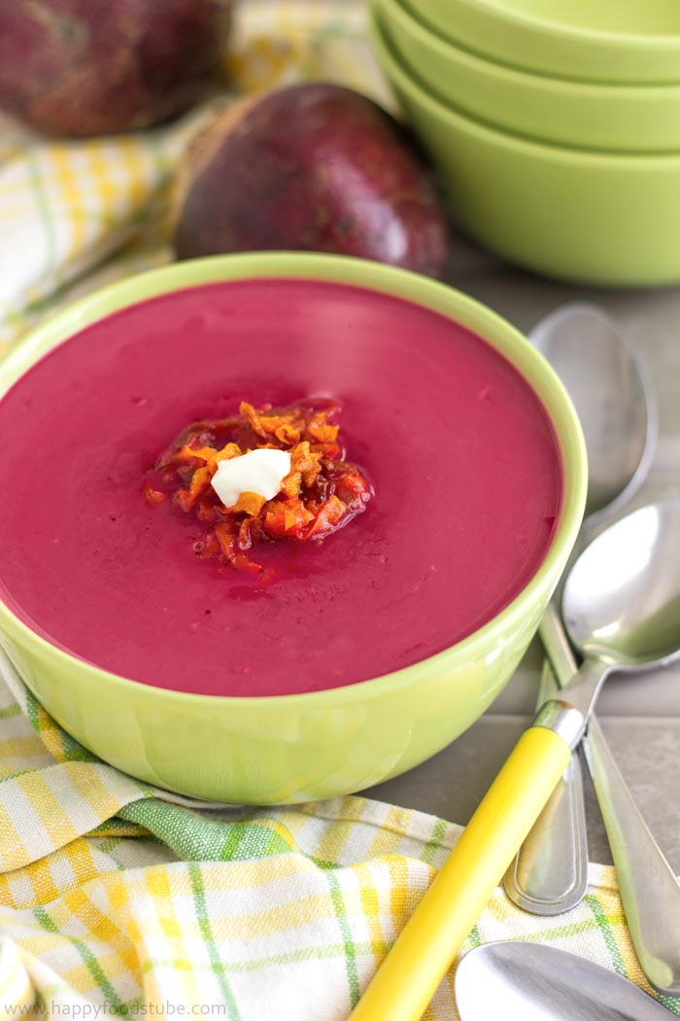
Credit:https://www.happyfoodstube.com/wp-content/uploads/2016/09/Oven-Roasted-Beet-Soup-with-Coconut-Easy-Recipe.jpg

Method of preparation :
- Wash well and peel the outer layer of beetroot and fresh ginger.
- Sliced both of them in medium size
- Take a vessel with water and bring it to boil then add sliced beetroot and ginger boil till the beetroot becomes soft.
- Take grinder add boiled beetroot and ginger along with require quantity of water add 1 tsp. of olive oil, salt and black pepper as per taste.
- Blend all together till the mixture turns into smooth texture.
- Add more water as desired to reach a creamy consistency then have it as fresh.

16. Split moong soup:

Ref : Morningstar A. Ayurvedic Cooking for All: Familiar Food Prepared with Ayurvedic Principles. 3rd reprint. New Delhi: Motilal Banarsidass Publishers Pvt. Ltd.; 2011. p. 106

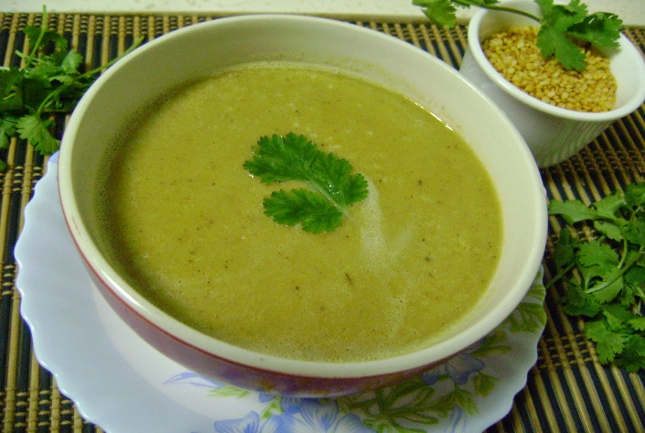
Credit:https://2.bp.blogspot.com/-itta7xvTYAU/VM3vs6iPlCI/AAAAAAAACo8/buII54QtKa8/s1600/Roasted%2BMoong%2BDal%2BSoup%2B3.JPG

Ingredients :
Split mung dal – 50 gm (1/4 cup)
Hingu – 1-2 gm (1/4 teaspoon)
Fresh ginger – 3 gm (1/2 teaspoon)
Coriander leaves – 8-10 gm (2 teaspoon)
Cumin – 5 gm (1 teaspoon)
Rock salt – to taste
Olive oil – 10 ml (1-2 teaspoon)

Total quantity : 380 -420 gm

Method of preparation :
- Take half cup of washed mung dal into a vessel with required quantity of water and bring it to boil.
- Also add fresh chopped ginger and hingu to the boiled vessel.
- Boil till the dal becomes soft and perfectly boiled.
- Take grinder add boiled content along with ginger and coriander leaves, cumin, rock salt as per the taste and olive oil.
- Blend it all together smoothly, add more water as desired to reach a creamy consistency then have it as fresh and hot.

17. Coconut Payasa(Nalikera Ksirika) :

Ref :
- Shri Ksema Sarmakrut Ksemakutuhalam Classical Treatise on health care, Dietetics and Cookery – Culinary Science (Sanskrit Text with English Commentary) By Prof.(Dr.Gyanendra Pandey) 12/7-8
- Dixit M, Joshi A, Joshi M. Development and sensory evaluation of Narikelakshirika (a coconut based pudding). Int J Mod Pharm Res. 2021;5(5):13-16.

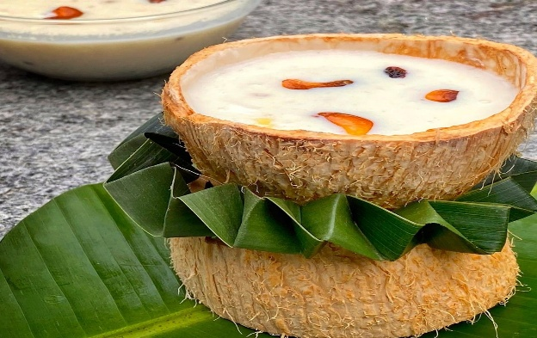
Credit:https://i.pinimg.com/originals/48/c1/5f/48c15f9a02d9512b1c00c39a9714dd2a.jpg

Ingredients :
- Grated coconut - 50 gm (1/4 cup)
- Milk - 240 ml (as needed)
- Rock sugar - 10 gm (to taste)
- Dry fruits (choice) - 10 gm (2 teaspoon)
- Aromatic powder - 1-2 gm (1/4 teaspoon)
- Ghee – 5 ml (1 teaspoon)
(Cardamom -3-4, Clove –2-3, Pepper – 2-3, Cinnamon – 2-3inch, Dry ginger – 2-3 inch, Edible camphor (pacha karpooram) – 2-3 small crystals – make all them into fine powder.)

Total quantity : 150-180 ml

Method of preparation :
- Take grated tender coconut and fry in ghee until it obtain a slight golden brown colour then to this add boiled milk and stir continuously until it becomes thicken consistency
- Then add desired quantity of sugar and stir continuously until it dissolved then add Aromatic powder and add chopped dry fruits roasted in ghee of your choice in the desired quantity and mix them well.

Contraindications:
- Diabetes
- Overweight / Obesity
- Lactose intolerance
- Sedentary life style with poor metabolism

18. Milk Delight (Pindaka):

Shri Ksema Sarmakrut Ksemakutuhalam Classical Treatise on health care, Dietetics and Cookery – Culinary Science (Sanskrit Text with English Commentary) By Prof.(Dr.Gyanendra Pandey)

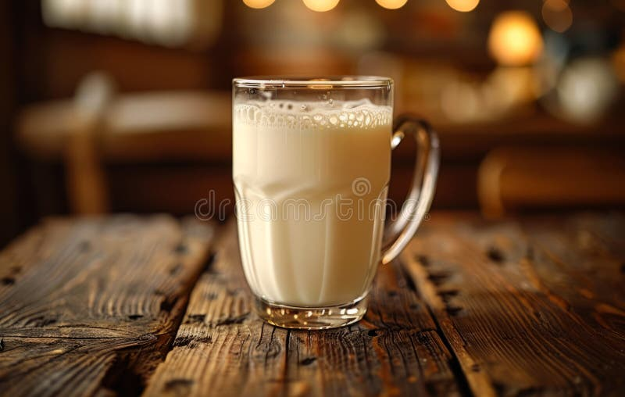

Credit:https://thumbs.dreamstime.com/b/glass-milk-sitting-wooden-table-glass-half-full-milk-white-glass-milk-sitting-wooden-314675616.jpg

Ingredients :
Cow’s milk – 150 ml
Rock sugar powder – to taste
Aromatic powder – 1-2 gm (1/4tsp)
(Cardamom - 4, Clove – 2, Pepper – 2, Cinnamon – 2inch, Dry ginger – 2 inch, Edible camphor (pacha karpooram) – 2 small crystals – make all them into fine powder)

Method of preparation :
- Take a vessel add 2cups of cow’s milk bring it to a gentle boil then add Rock sugar as per the required taste stir it well until completely dissolved.
- Boil the milk until it reaches a mildly thick consistency.
- Then add 1/4tsp. of aromatic powder mix well cook for another 2-3min. and switch off the flame. Serve hot / warm.

Contraindications:
- Diabetes
- Overweight / Obesity
- Lactose intolerance
- Sedentary life style with poor metabolism

19. Revitalizing Milk (Mashadi Ksheerapaka):

Ref :
- Bhaishyaja Ratnavali verse 17
- For the general method of Ksirapaka preparation:Sarngadhara Samhita, Madhyama Khanda, Ksirapaka Kalpana

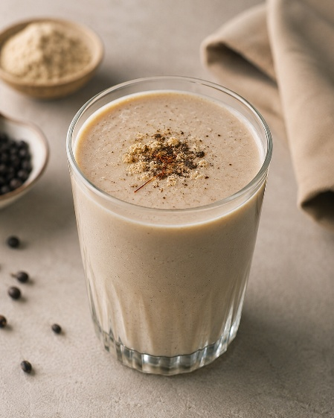
Image created with the use of AI

Ingredients :
Black gram powder – 20 gm (4 teaspoon)
Ghee – 10 gm (2 teaspoon)
Milk – 200 ml (as needed)
Rock sugar powder – 10 gm (to taste)

Method of preparation :
- Take a ghee in pan and heat it on medium flame then add black gram powder and roast it till the powder turns into golden colour then add a glass of milk bring it to a gentle boil then add Rock sugar powder as per the required taste stir it well until completely dissolved. Boil the milk for 2-3min. and switch off the flame. Serve hot / warm.

Contraindications:
- Diabetes
- Lactose intolerance

20. Ginger milk : P. No: 269

Ref : Morningstar A. Ayurvedic Cooking for All: Familiar Food Prepared with Ayurvedic Principles. 3rd reprint. New Delhi: Motilal Banarsidass Publishers Pvt. Ltd.; 2011. p. 269

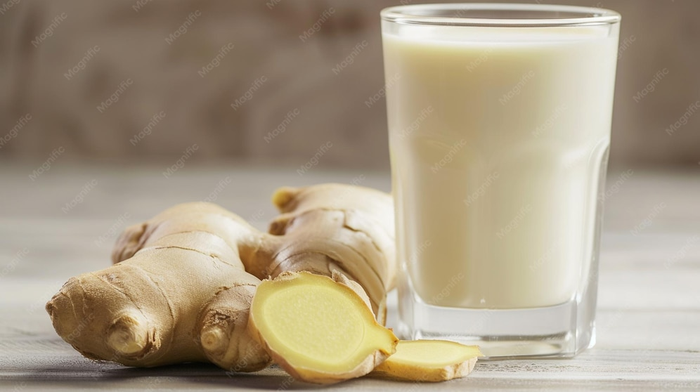
Credit:https://img.magnific.com/premium-photo/glass-milk-gingers-table_949067-34609.jpg?w=996

Ingredients :
Milk – 100 ml
Water – 100 ml
Fresh ginger paste – 3-4 gm (1 teaspoon)
Honey – 5 gm (to taste)

Total quantity : 200-240 ml

Method of preparation :
- Take a vessel add milk and water heat it on flame then add ginger paste and boil it for 3-5 min. and reduces it to 1 cup of the quantity
- After that remove from heat, strain and serve with honey as per the taste and honey is optional.

21. Restorative almond drink :

Ref : Morningstar A. Ayurvedic Cooking for All: Familiar Food Prepared with Ayurvedic Principles. 3rd reprint. New Delhi: Motilal Banarsidass Publishers Pvt. Ltd.; 2011. p. 275

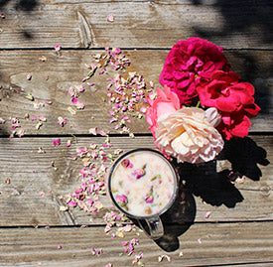
Credit:https://www.banyanbotanicals.com/cdn/shop/articles/restorativeAlmondDrink_landing_bc67002f-857f-42e1-b52f-95902e808770.jpg?v=1717708842
Ingredients :

Almond – 10 gm
Milk – 180-200 ml
Water – 240 ml (for soaking)
Rose petals – 2 gm
Saffron (optional) – 2 strands
Cardamom powder – 2-3 gm (1/2 teaspoon)
Honey – to taste

Method of preparation :
- Soak the almond overnight with water, and rub the skins off the almonds.
- Take a blender add milk and water, soaked almonds, Cardamom powder, Saffron, rose Petels and honey blend until it turns to smooth structure then drink it.

22. Almond milk :

Ref : Morningstar A. Ayurvedic Cooking for All: Familiar Food Prepared with Ayurvedic Principles. 3rd reprint. New Delhi: Motilal Banarsidass Publishers Pvt. Ltd.; 2011. p. 277

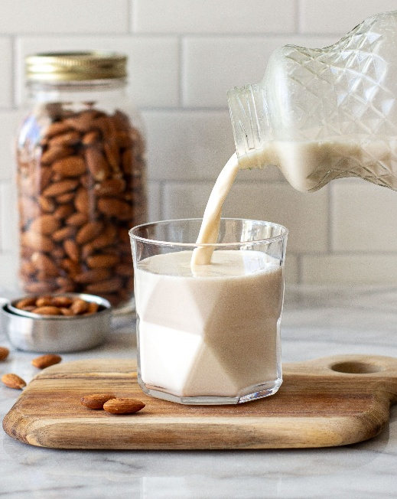
Credit:https://foodbyjonister.com/wp-content/uploads/2018/02/AlmondMilk2-scaled.jpg

Ingredients :
Almond – 14 gm
Water – 240 ml

Total quantity : 240-250 ml

Method of preparation :
- Soak the almond overnight with water, and rub the skins off the almonds.
- Take a blender add soaked almond and required quantity of water and blend until it turns to smooth.
- Then strain it through the strainer for smoother consistency.
- Then have it with honey. Honey is optional for the sweetener.

23. Almond milk :

Ref :Gowans S. Food for Life: Ayurvedic Recipes. Chennai: Shanti Gowans; 2009. P.no 131

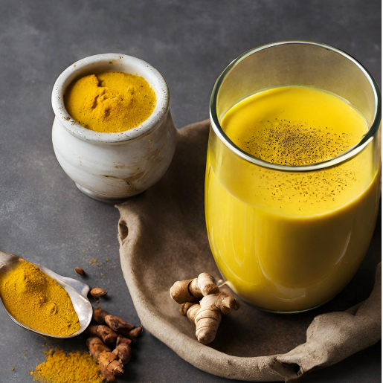
Credity:https://prakritisattva.com/cdn/shop/articles/Golden_Milk.png?crop=center&height=1000&v=1743291480&width=1000
Ingredients :
Milk – 200 ml
Water – 200 ml
Crushed cardamom – 2-3
Ginger paste – 2-3 gm (1/2 teaspoon)
Turmeric powder – one pinch

Total quantity 240 ml

Method of preparation :
- Take a vessel add a cup of milk and a cup of water bring to boil
- After it starts to boiling then add Crushed cardamom, ginger paste and a pinch of turmeric powder
- Boil up to it reduces half the quantity that is 1 cup.
- Strain the cardamom pods and ginger and have it as hot.

